CAREPAL - HEALTH & WELLNESS ASSISTANT

Data Source
Pdf Files
Physical Activity Guidelines for Americans – CDC, WHO & US department of health services
Text Chucks

Text Chucks

Text Chucks

Text Chucks
Extract Data / Content

Pre-Processing , removing stop words,
unwanted spaces and characters

User


Question
Embeddings
Embeddings
Embeddings
Embeddings
Query Embedding
[0.1,0.2,0.3]
Response
(Relationship) King + Queen
Build Semantic Index

Pinecone Vector Store
Question
Knowledgebase
LLM
Model
Ranted Results
Knowledgebase

Corpus
Bouts, or episodes, of moderate-to-vigorous physical activity of any duration may be included in the daily accumulated total volume of physical activity. The 2008 Physical Activity Guidelines for Americans recommended accumulating moderate-to-vigorous physical activity in bouts of 10 minutes or more because not enough evidence was available to support the value of bouts less than 10 minutes in duration. The 2018 Advisory Committee concluded that bouts of any length contribute to the health benefits associated with the accumulated volume of physical activity. Even a brief episode of physical activity like climbing up a few flights of stairs counts.

Token – Combining three characters together, you call it as a tokens.
You can consider words as a token.

“The token limits define the maximum length of text (in tokens) that each model can process in a single input sequence.”
After combining our three datasets, we found that the token size is 7,068, which significantly exceeds the model's expected limit.
The token limits for the models you've inquired about are as follows:
- Llama 2: This model has a context window of 4,096 tokens, allowing it to process sequences up to this length.
- BioBERT: BioBERT is based on the original BERT architecture, which has a maximum sequence length of 512 tokens. Therefore, BioBERT inherits this 512-token limit.
- ClinicalBERT: ClinicalBERT is also derived from BERT and retains the same maximum sequence length of 512 tokens.

What to do now…???
Thus, researchers introduced a term “Text Chucks”

Chuck_size = 200

Bouts, or episodes, of moderate-to-vigorous physical activity of any duration may be included in the daily accumulated total volume of physical activity. The 2008 Physical Activity Guidelines for Americans recommended accumulating moderate-to-vigorous physical activity in bouts of 10 minutes or more because not enough evidence was available to support the value of bouts less than 10 minutes in duration. The 2018 Advisory Committee concluded that bouts of any length contribute to the health benefits associated with the accumulated volume of physical activity. Even a brief episode of physical activity like climbing up a few flights of stairs counts.

What is chunk overlap?
Chuck_overlap = 20
Bouts, or episodes, of moderate-to-vigorous physical activity of any duration may be included in the daily accumulated total volume of physical activity. The 2008 Physical Activity Guidelines for Americans recommended accumulating moderate-to-vigorous physical activity in bouts of 10 minutes or more because not enough evidence was available to support the value of bouts less than 10 minutes in duration. The 2018 Advisory Committee concluded that bouts of any length contribute to the health benefits associated with the accumulated volume of physical activity. Even a brief episode of physical activity like climbing up a few flights of stairs counts.

- How to use Pinecone? Get API key?
Potential Users of our Chatbot
- Healthcare Professionals:
  - Doctors
  - Nurses
  - Physical therapists
  - Healthcare administrators
- General Public:
  - Individuals seeking health and fitness advice
  - Patients managing physical activity goals
- Researchers and Students:
  - Medical and healthcare researchers
  - University students studying healthcare, fitness, or related fields
- Fitness Trainers and Coaches:
  - Personal trainers
  - Gym instructors
  - Sports coaches

End Goal
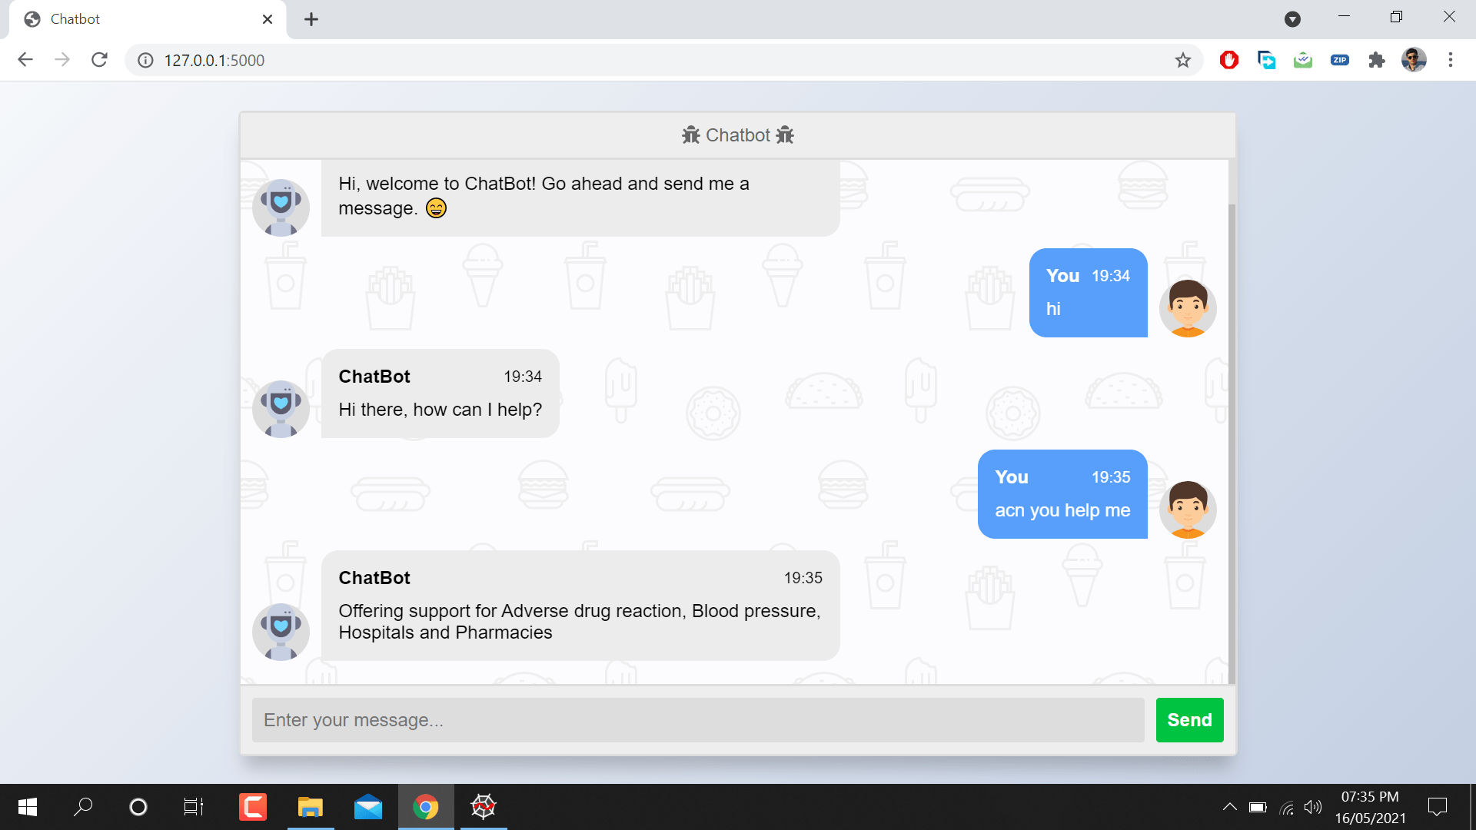

Source: https://buffml.com/web-based-chatbot-using-flask-api/

